Section D — AI-Augmented Learning
1.Implements a POST /api/orders/place/ endpoint using DRF APIView that accepts customer_name, item, and quantity in the request body.
2. Validates that quantity is a positive integer and returns a JSON error response with HTTP 400 if the validation fails.
3. Saves the order to the database and returns the saved order details (including the auto-generated id) with HTTP 201 on success.
4. Can be tested end-to-end using Postman — demonstrate at least one successful request and one validation-failure request in screenshots.
Ans=
1
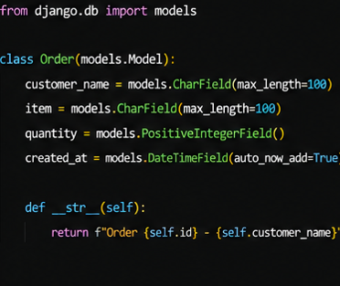
2
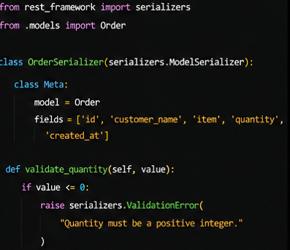
3
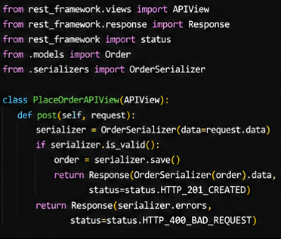
4
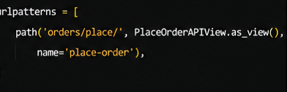
5
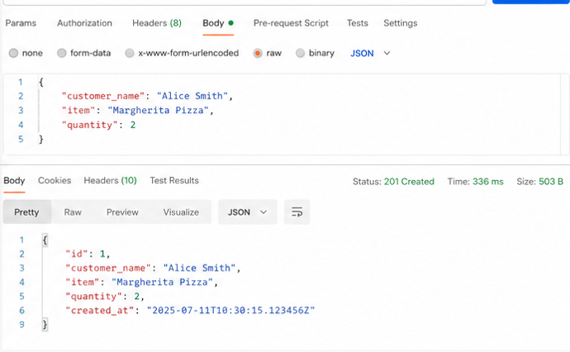
6
